Registration will not be complete, and seats will not be held for families without all the required documents below:

- Proof of the student's age (original birth certificate or passport),
- The student's up-to-date immunization records,
- The Pre-K student's latest yearly lead test results,
- Your valid driver's license or passport, and
- One (1) of the following documents verifying proof of St. Louis City residency:
  - A residential utility bill (gas, electric, or water) in the resident's name, issued by a utility company and dated within the last 60 days.
  - A lease agreement in the parent/guardian’s name, indicating utilities are included
  - Documentation or letter on letterhead from a federal, state, or local government agency, including the IRS, City Housing Authority, or the federal Office of Refugee Resettlement, indicating the parent/guardian’s name and address within the last 60 days
  - Voter registration documents, which include the name of the parent/guardian and the address of the residence
Click HERE to see your St. Louis Public School based on your Address: (Note: Picture below then displayed )Next type your address for your neighborhood and the school zones to display.) Need Assistance? Contact 314-633-5200 for support.
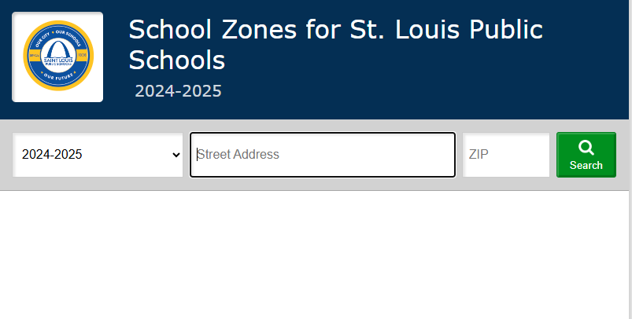
When all forms are complete, a Submit and Finish button will appear at the bottom of the page.
Click Submit and Finish to send your information in for approval.
St. Louis Public Schools Registration - St. Louis Public Schools

For Students in Transition: Please call 314-345-5750 or visit the Student in Transition office at
801 N. 11th St. for additional information or assistance.

For ELL families: Please call 314-664-1066 or visit our ESOL office at 1530 S. Grand Blvd for additional information or assistance.

The Department of Gifted Education: It your child meets age criteria of 3.6 years old to age 18 to be tested please contact: Shelice Hardin (314) 345-4548 shelice.hardin@slps.org

For the Office of Early Childhood: Please call 314-331-6150, and email ECE@slps.org.
ECE Website link: Early Childhood / Early Childhood Education. Registration for the 2025-2026 school year is open now! Please create an account in Focus, our Student Information System, to register.

For Returning Parents: If you’ve already submitted an Intent to Return form but need to make an update, please email Register@SLPS.org. For a change of address update(s), school zone?

Please provide current proof of residence to your child’s school:
Acceptable Proof of Residence documents are Current Utility Bills (Spire, Ameren, MSD), Apartment Lease, House Deed, or Notarized Address document.

